 | BAHRIA UNIVERSITY, (Karachi Campus)  Department of Software Engineering  Assignment 3 - Spring 2021

COURSE TITLE: Linear Algebra COURSE CODE: Gsc-121
Class: BSE-2(B) Shift: Morning
Course Instructor: Muhammad imran afridi Time Allowed: 2 Days
Submission Date: 08 Jun 20201 Max. Marks: 5 Marks

Assignment No. 03, (CL02) [5 Marks]
1.Determine the values of ‘a’ such that 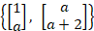 is linearly independent.
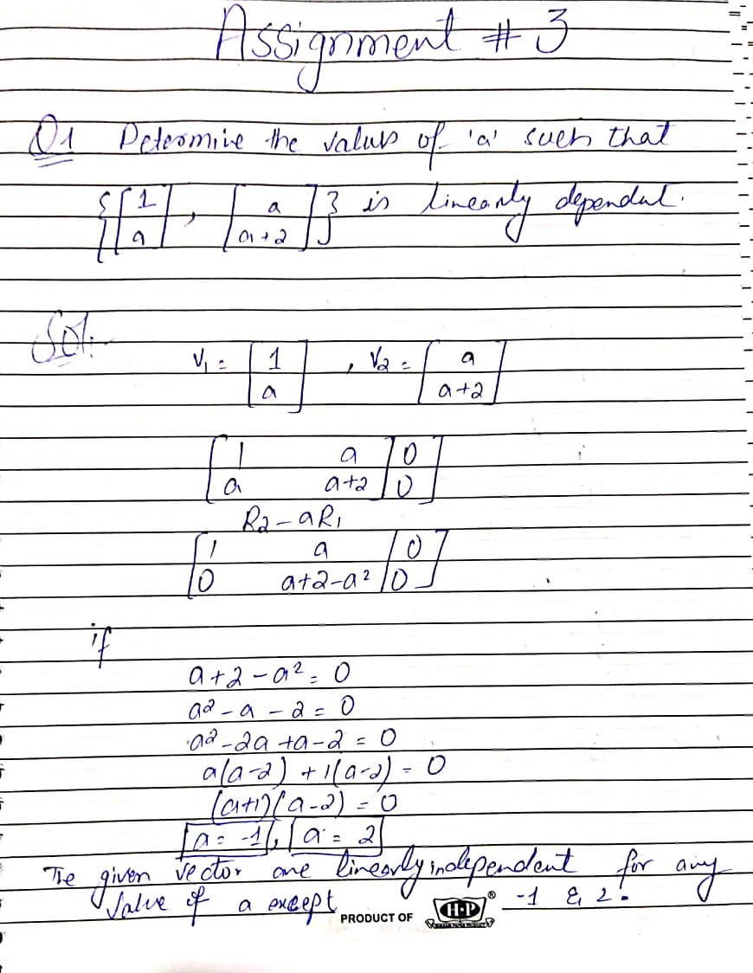

2.(a) Find the bases for Null A and Col A. Also list the rank A and Dimension of Null A.
Where 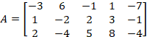
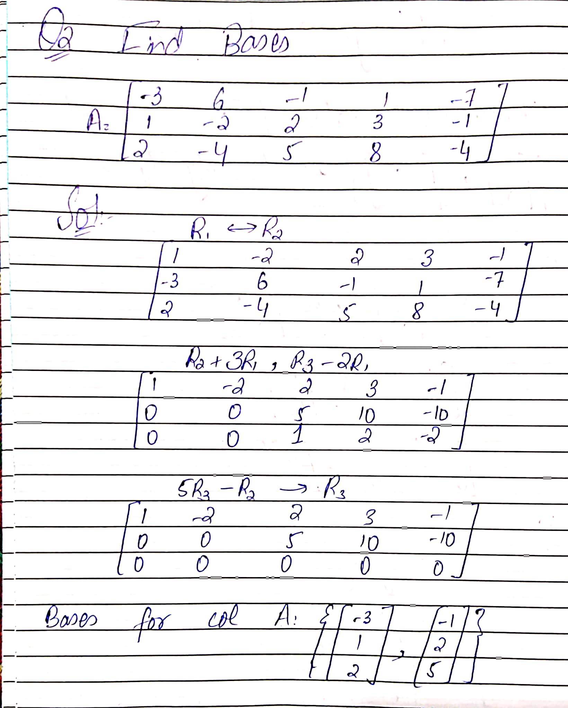
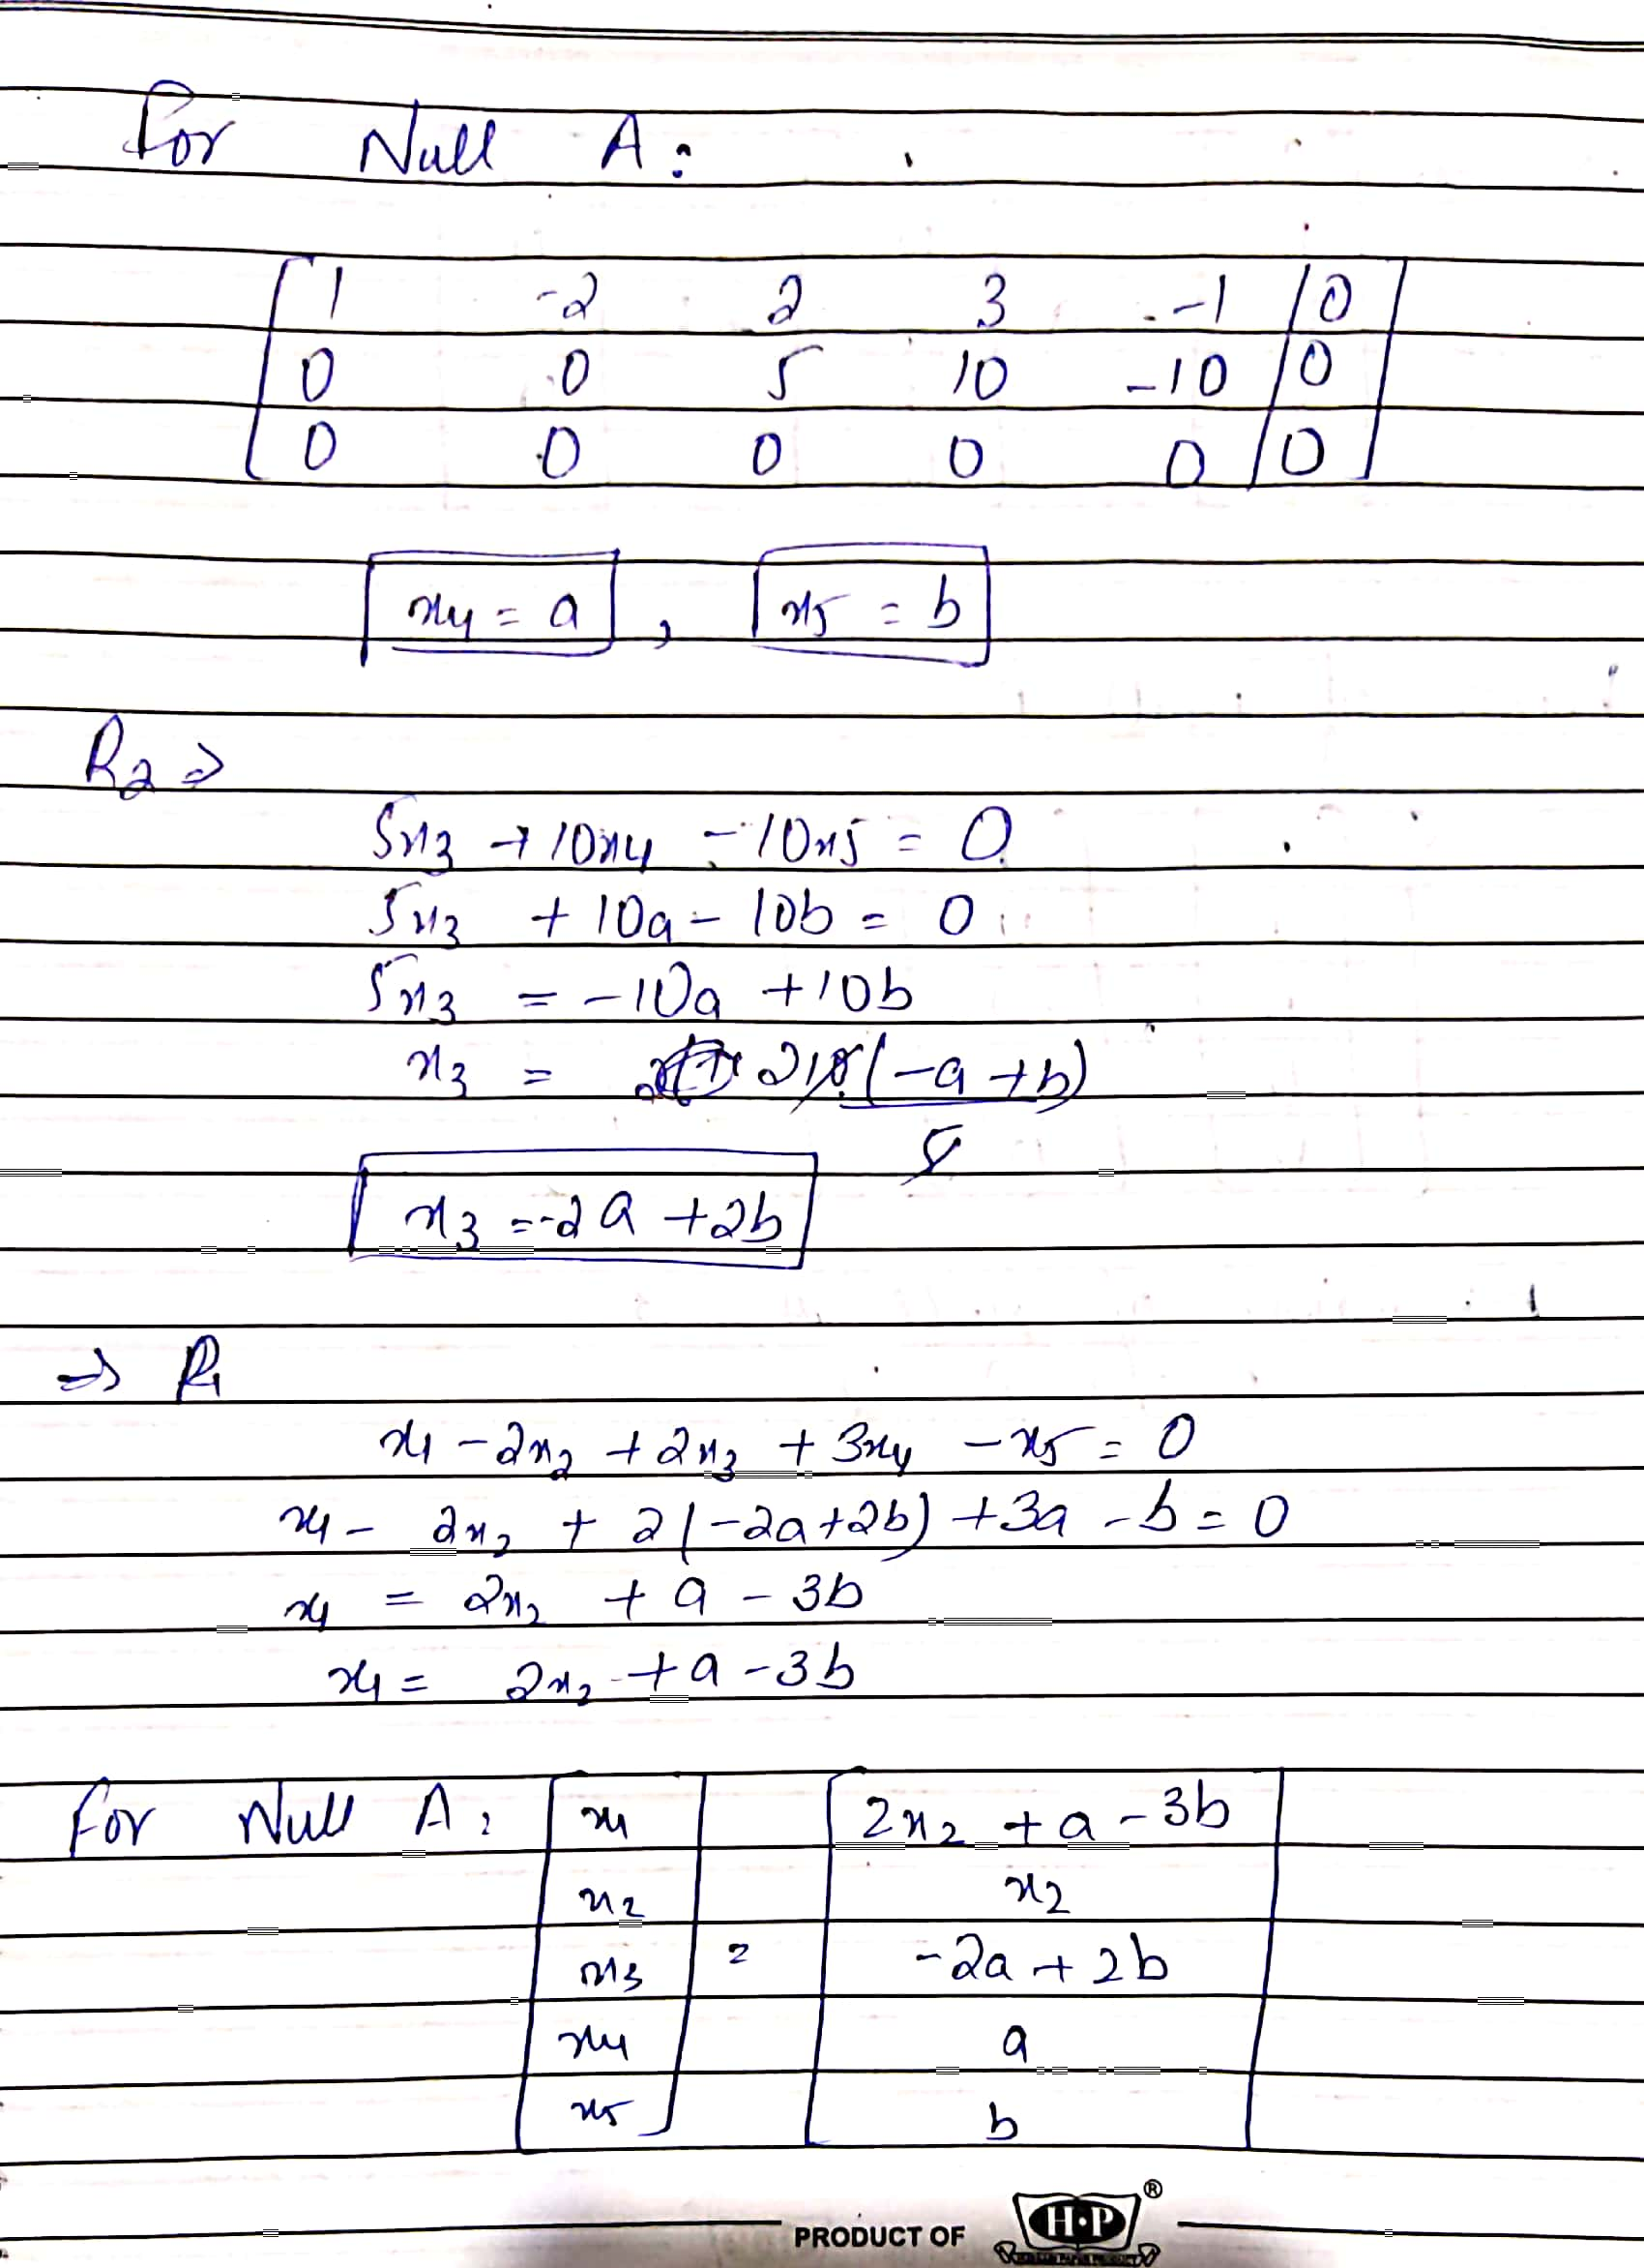
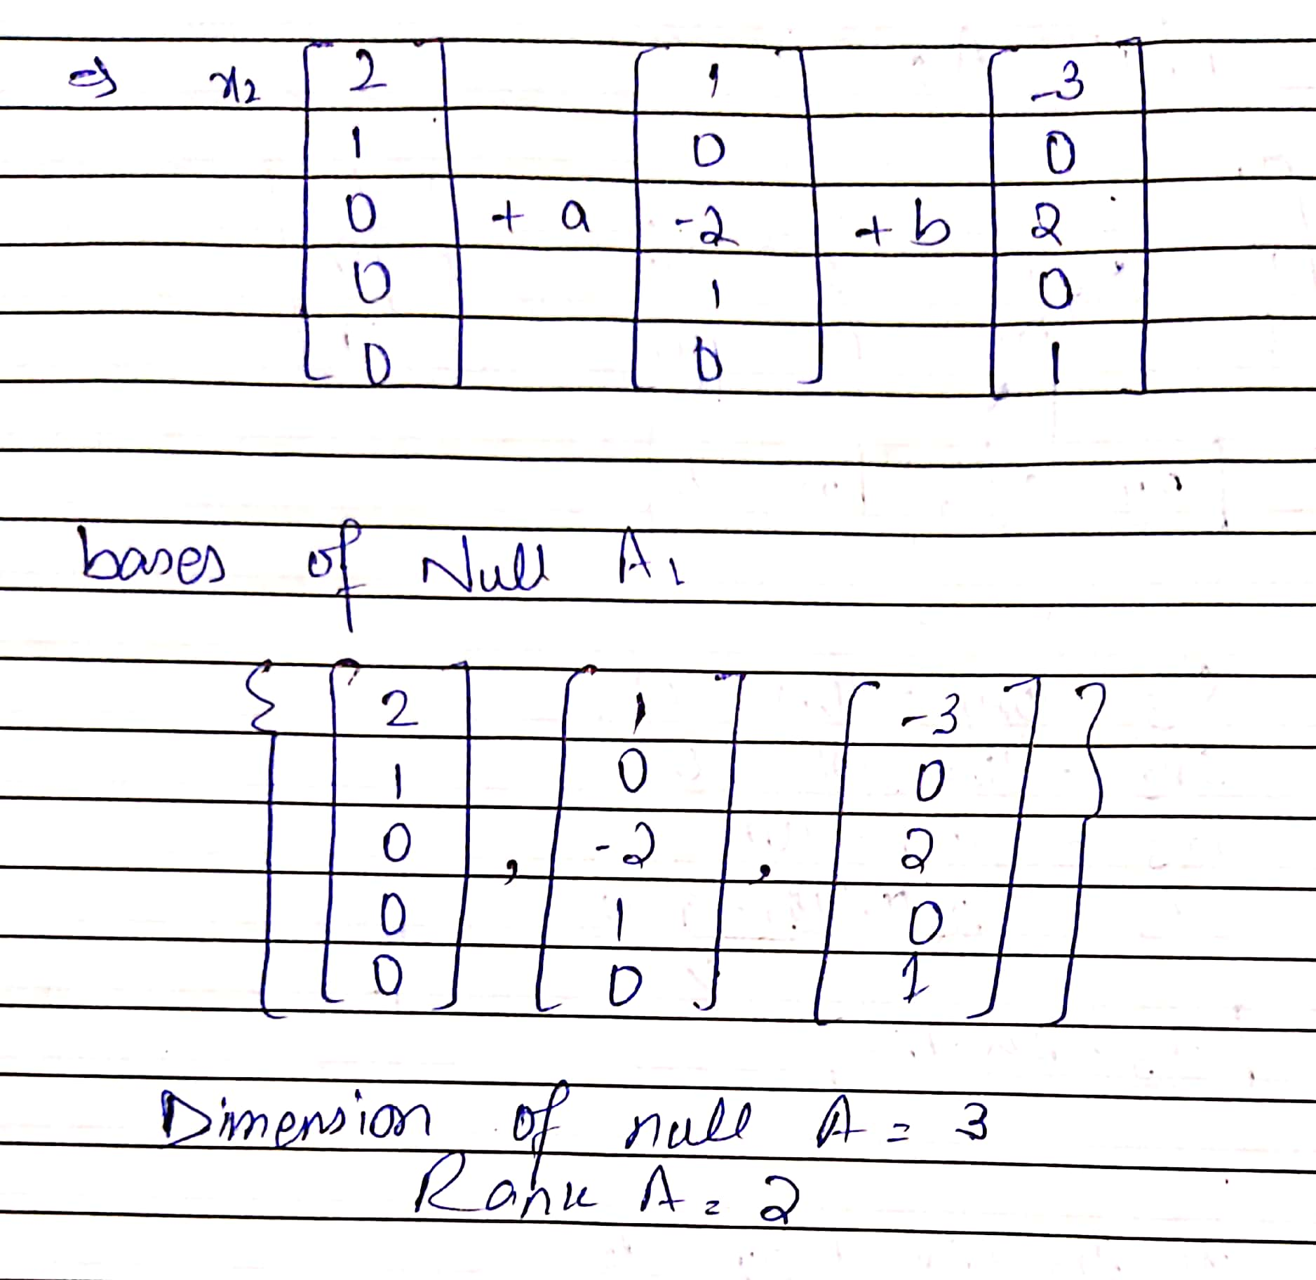

3.The set is a basis for find the coordinate vector of
